*CREATE THE DATABASE.
*USE THE DATABSE & CREATING THE STUDENT TABLE.
*INSERTING THE VALUES IN STUDENT TABLE.
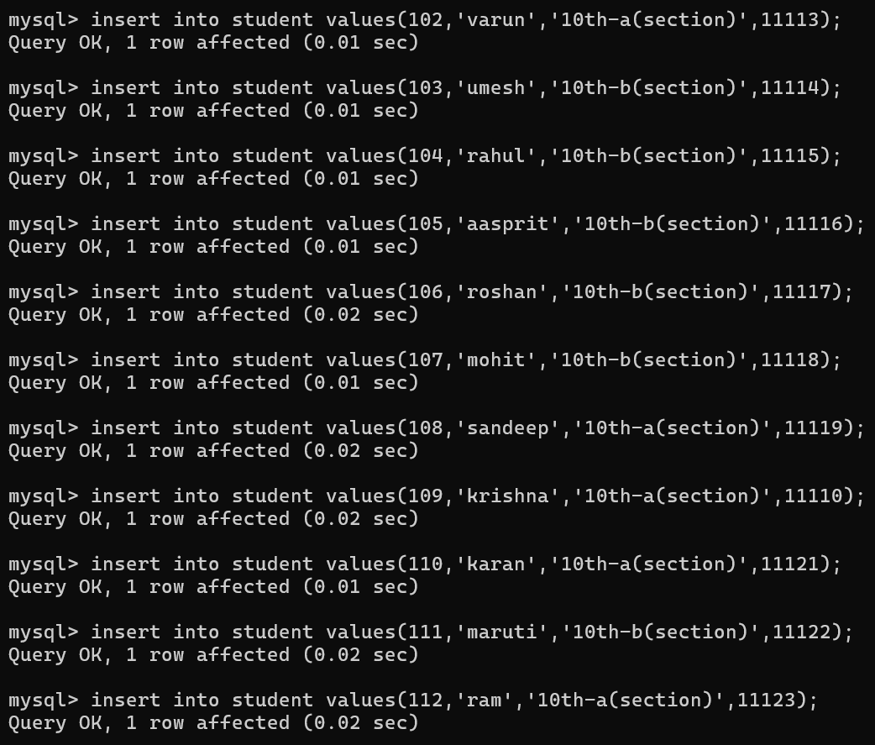
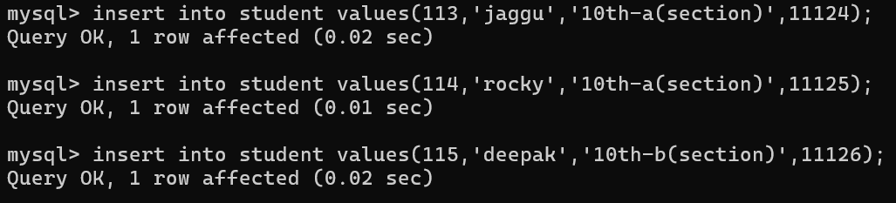

*ATTENEDENCE TABLE.
